Environmental impact statement process
Have your say on an environmental impact statement
FACT SHEET
Queensland’s Coordinator-General has the power to declare a project a ‘coordinated project for which an environmental impact statement (EIS) is required’ under Part 4, section 26(a) of the State Development and Public Works Organisation Act 1971 (SDPWO Act).
The declaration triggers the requirement for a project proponent to prepare an EIS and submit it to the Coordinator-General. The purpose of an EIS is to examine and address the project’s potential direct and indirect environmental, social and economic impacts.
Once the Coordinator-General decides the EIS is acceptable, it is released for public and state government advisory agency consultation for a six- week period.

Why am I being consulted?
The public and government advisory agencies are invited to make a submission on the EIS, including the project’s potential environmental impacts and the effectiveness of measures the proponent proposes to manage those impacts.

Where are consultations advertised?
A list of open public consultations is available at
https://haveyoursay.dsd.qld.gov.au
A public notice also appears in state and local newspapers at the start of the consultation process.

How do I make a submission?
Visit https://haveyoursay.dsd.qld.gov.au or read the public notice for details about how to make a submission and the consultation closing date. You can make a submission using one of the following methods:
- Online visit https://haveyoursay.dsdip.qld.gov.au
- Email, post or fax—refer to the public notice or the above website for details.
If you are sending your submission by email, post or fax, you may either complete and send the attached submission form or provide a written submission that meets the requirements set out on the next page.

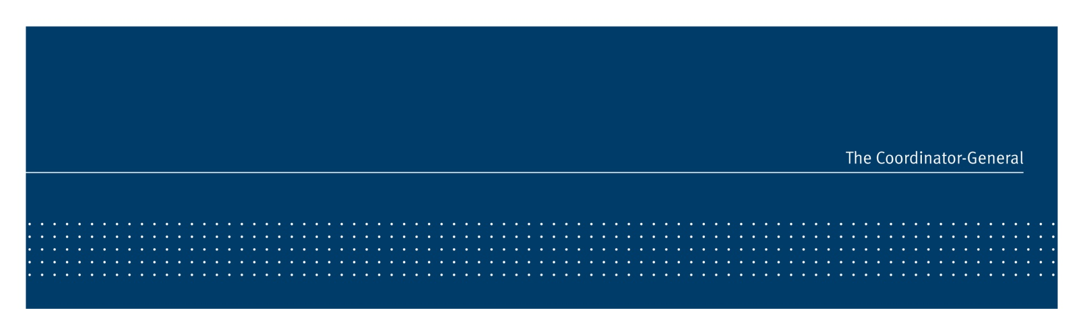


Submission checklist
When making a submission:
- clearly state the matter(s) of concern or interest and list points to help with clarity
- reference the relevant section(s) of the EIS
- provide factual information relied upon and its source
- describe the measure you consider would be appropriate to improve the proposal
- provide sketches or diagrams if they assist to clarify your submission
- ensure your submission is legible.
Note: Under section 157O of the SDPWO Act, it is an offence to give the Coordinator-General a document that contains information known to be false or misleading.

‘Properly made’ submissions
Under the SDPWO Act, the Coordinator-General is not obliged to consider a submission that is not ‘properly made’. Also, to ensure you have appeal rights under the Sustainable Planning Act 2009, your submission must be ‘properly made’.
For a submission to be ‘properly made’, it must:
- be made to the Coordinator-General in writing
- be received on or before the last day of the submission period
- be signed by each person who makes the submission (or submitted online)
- state the name and address of each person who makes the submission

- state the grounds of the submission and facts and circumstances relied on.

What happens next?
After consultation closes, the Coordinator-General evaluates the EIS, submissions on the EIS and any additional information provided by the project proponent. The Coordinator-General then writes an evaluation report, either approving or refusing the project.

Privacy
The Coordinator-General is authorised to collect personal information under Schedule 2 and section 29 of the SDPWO Act. Your personal information will be used for the purpose of considering your submission, completing the EIS process and the performance of functions under the Act and other legislation relevant to the proposed project.
Your personal information will be disclosed to the project proponent and other government agencies involved in the proposed project, and is also subject to disclosure under the Right to Information Act 2009. Your personal information will not otherwise be disclosed, unless disclosure is authorised or required by law, or is permitted under the Information Privacy Act 2009.

More information
If you have a question about a particular consultation, please contact the relevant EIS project manager (see the public notice or the website for contact details).
General information about the Coordinator- General’s EIS evaluation process is available at www.dsd.qld.gov.au/cg

© State of Queensland, February 2014. Published by the Department of State Development, 63 George Street, Brisbane Qld 4000, Australia. While every care has been taken in preparing this publication, the State of Queensland accepts no responsibility for decisions or actions taken as a result of any data, information, statement or advice, expressed or implied, contained within.

Department of State Development
PO Box 15517, City East Qld 4002
tel 13 QGOV (13 74 68)
fax +61 7 3452 7486
info@statedevelopment.qld.gov.au
www.dsd.qld.gov.au | - 2 -

Submission form: environmental impact statement (EIS)
Please complete this form only if you wish to provide a submission by email, post or fax. To make an online submission, visit https://haveyoursay.dsd.qld.gov.au

Name of project

………………..………………………………………………………………………………………………………………………………………………………………………………………………………….
Please write the project name exactly as it appears in the newspaper public notice or at https://haveyoursay.dsd.qld.gov.au

Your details (please print)
Full name  ……………………………………………………………………………………………………….…… |  | Organisation (if relevant)  ……………………………………………………………………………..……………………….
Postal address |  | Phone number (……….) ………………………………………………....……
…………………………………………………………..……………………..…………...…..………….
…………………………………………………………………………...……………………..………….
Email address

………………………………………………………………………………...……………………...
………………………………………………….……………Postcode .……………………………….
Signature | ………………………………………………………………  A submission by more than one person must be signed by each submitter | Date | ……../……../20……….

Your comments on the EIS (please print)
Section—e.g. water quality | Describe the issue | Suggested solution

  - If there is not enough space on this form, please attach additional pages. Please write your full name and the name of the project on any separate pages.
  - Send the completed form to the email/postal address/fax number shown in the newspaper public notice. If you require assistance, please telephone 13 QGOV (13 74 68).
  - You must provide your comments by the closing date shown in the public notice and on the consultation website.
  - For this submission to be ‘properly made’, it must be signed by each person who makes the submission and state the name and address of each person who makes the submission.

